**Project 3**

**Integrate Grafana with Linux Server for high cpu utilization and create a graph in Grafana.**

📄 Table of Contents

* Objective
* Tools used
* Steps to implement

**🧩 Objective:**

To integrate Grafana with a Linux server to visualize CPU utilization metrics and trigger alerts on high CPU usage.

**🛠️ Tools Used:**

* **Grafana** (Visualization tool)
* **Linux Server** (Ubuntu/CentOS)
* **Optional:** Alertmanager (for email/slack alerts)

**Pictorial representation**



* **Steps to Implement:**

**Create an Ec2 Instance**

1. Go to the [AWS Management Console](https://console.aws.amazon.com/)



1. Navigate to **Ec2**
2. Click **launch instance**

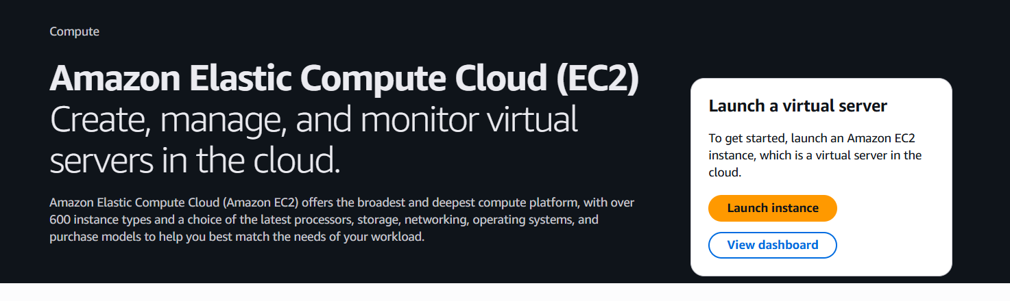

* + **Instance name**: e.g., my-static-site
  + **Region**: Choose region ap-south1
  + Click launch instance

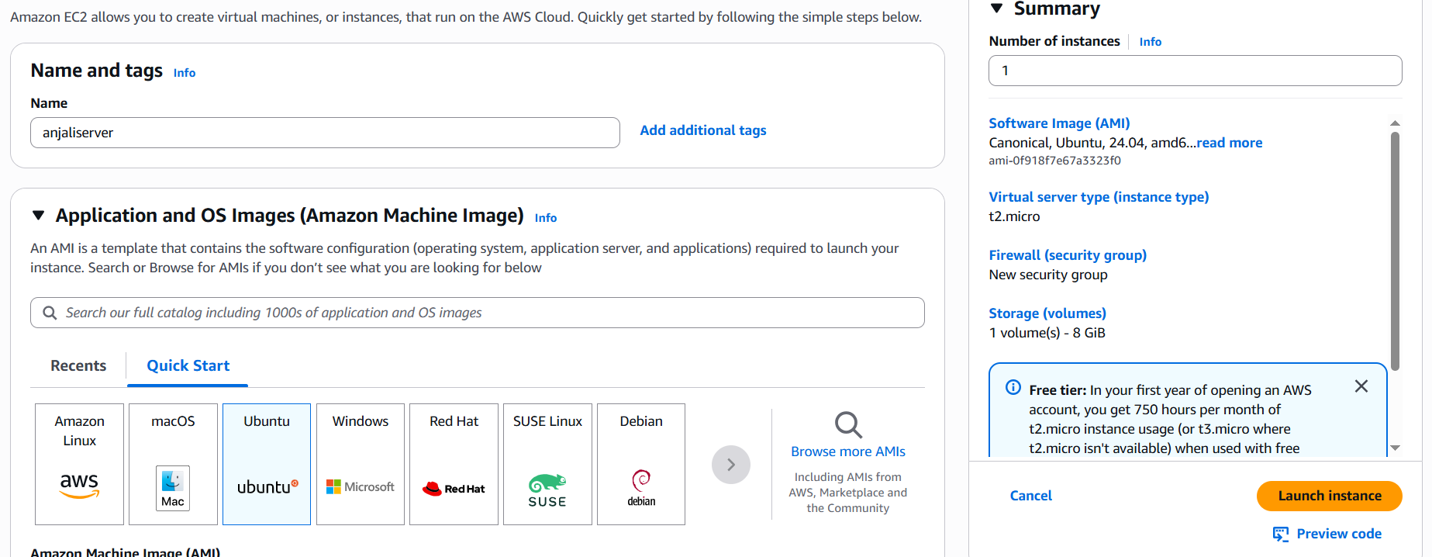

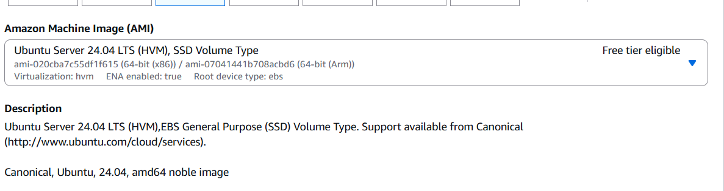

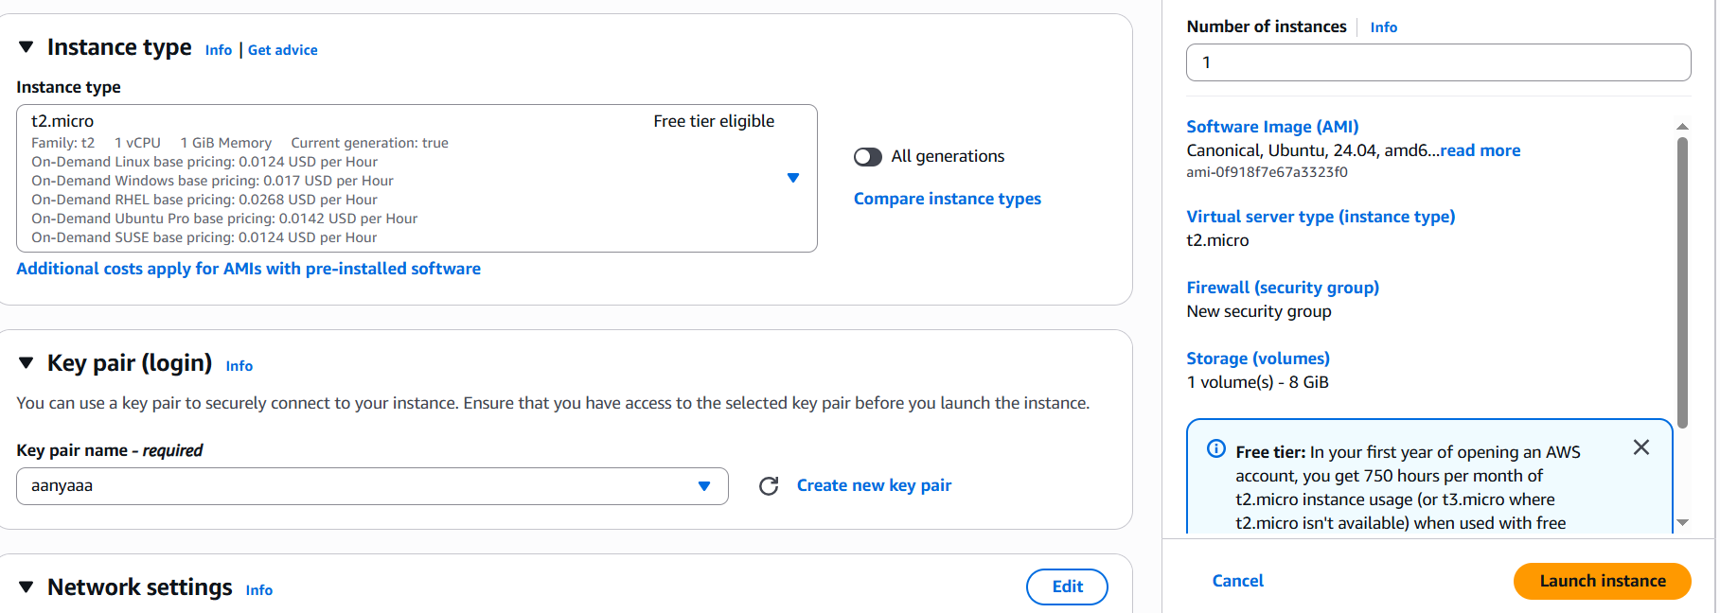

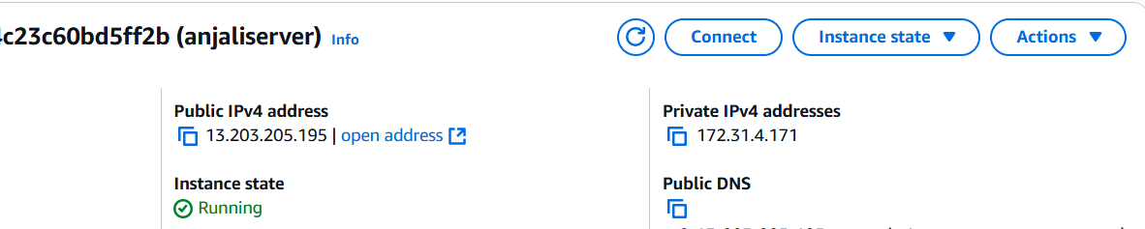

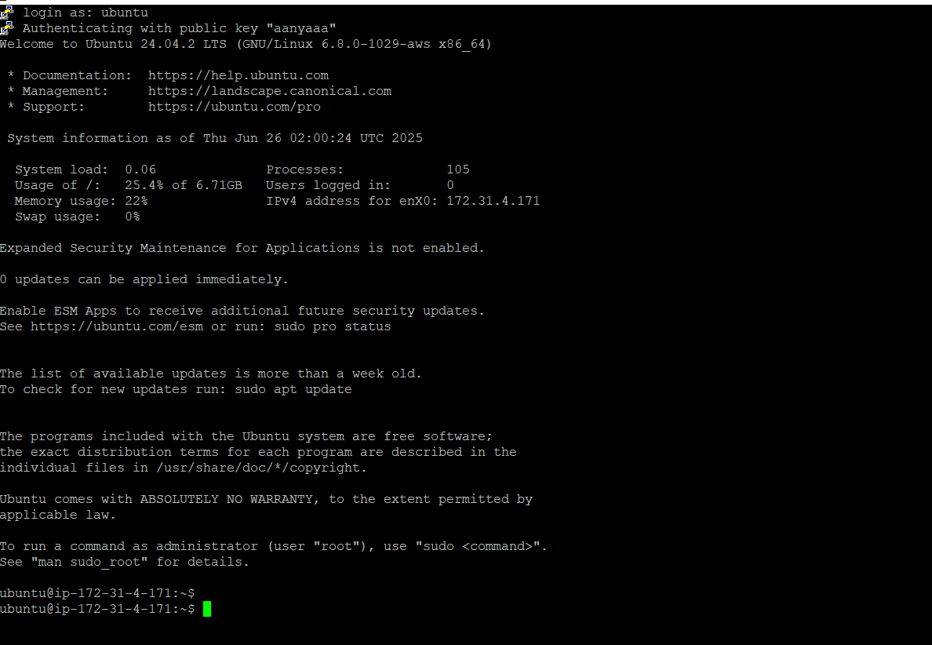

After create Linux server, we have to run all these commands one-by-one which are given below:







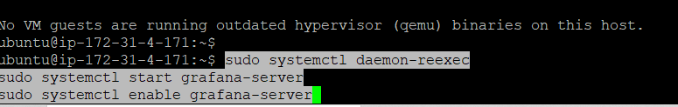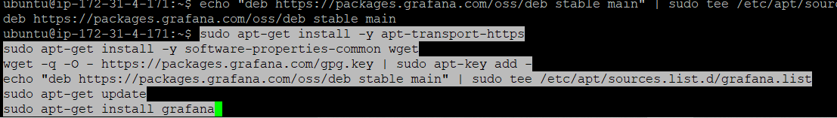



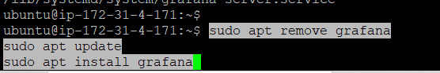





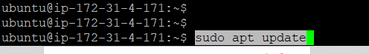









* Now go to the security group of your instance.
* Click on your security group id.
* Then click on **edit inbound rules.**

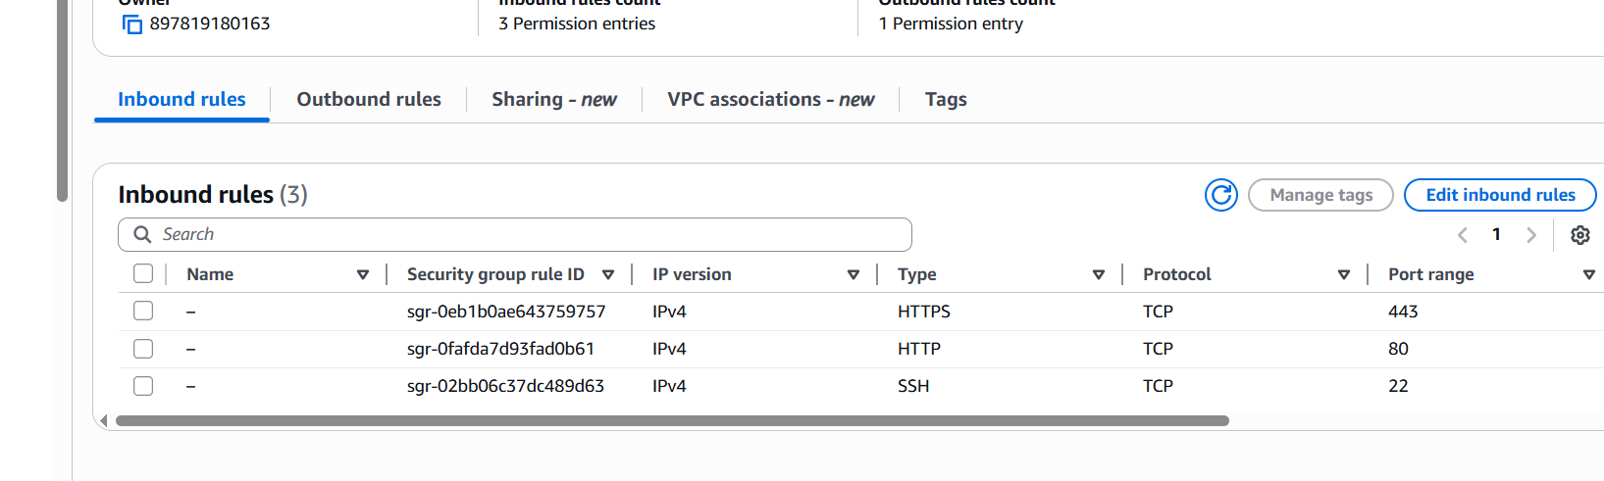

* Click on add rule
* Then change as given below:

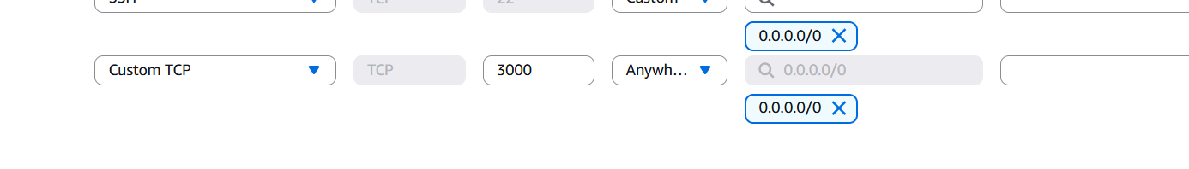

**Now your Grafana is installed**

* Create username and password as admin and click on log in
* After this you have to create new password.



* Now go to the connections and then data source.
* Search cloud watch on the search pannel.

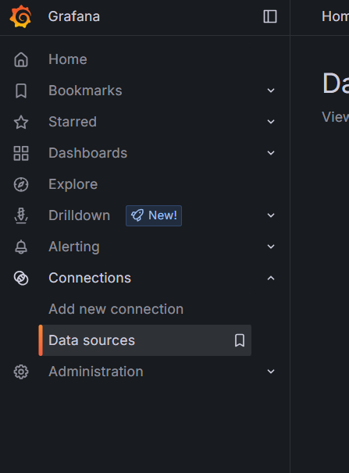

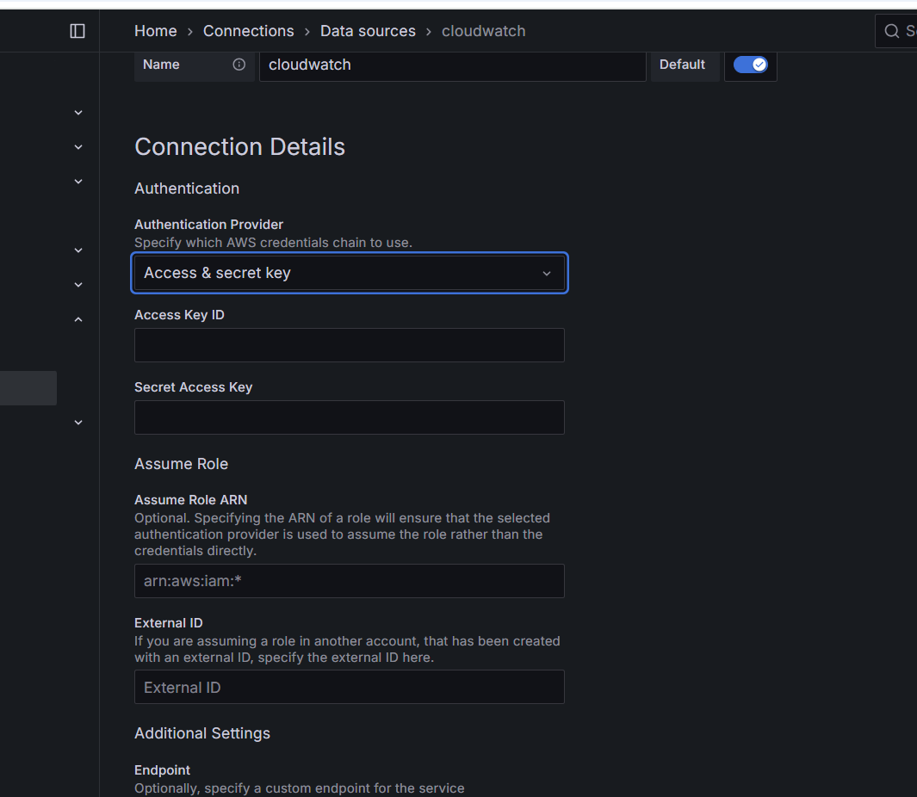

* Now go to iam and click on user.
* And then create access key.

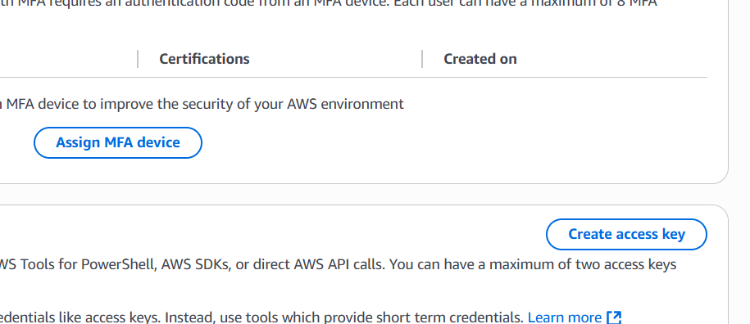

* Click on CLI and then click on next.
* Ignore the second step and then click on create access key.

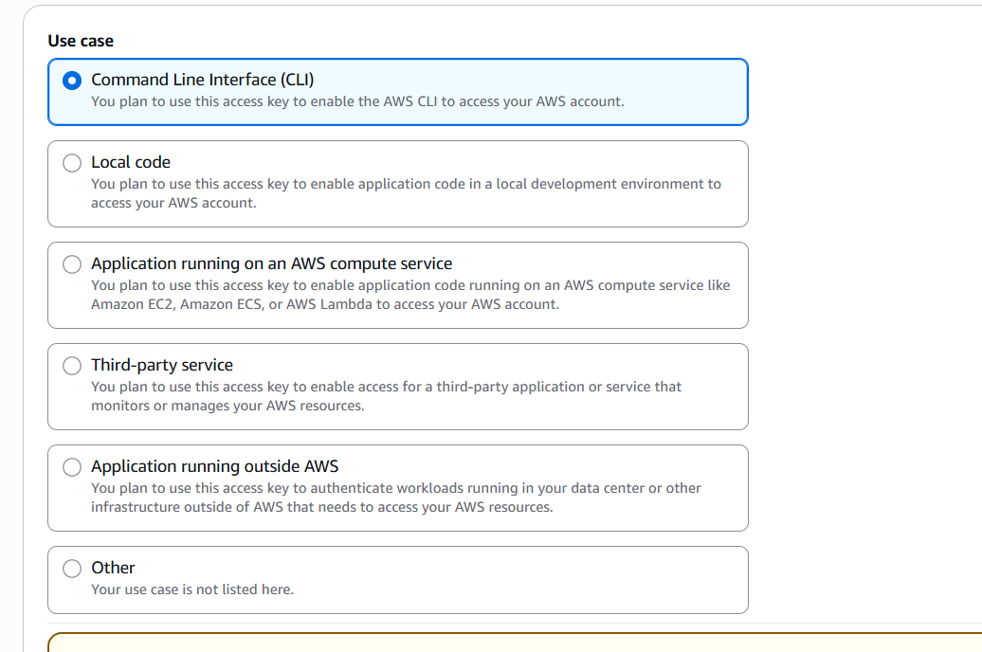

* And then copy the access key and secrete access key.
* And paste on the Grafana dashboard.
* And select the region ap-south-1
* Then click on save & test.
* Go to the dashboard and click on import dashboard.
* Search AWS EC2.
* Then copy the id and paste on the dashboard.

**After all these steps graph in Grafana will look like this ….**

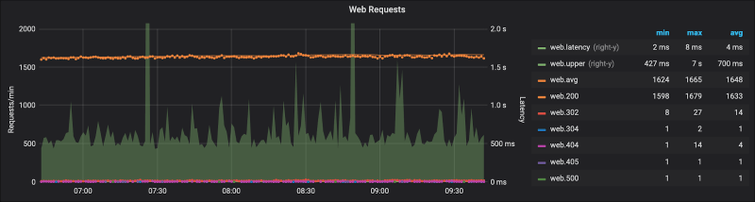

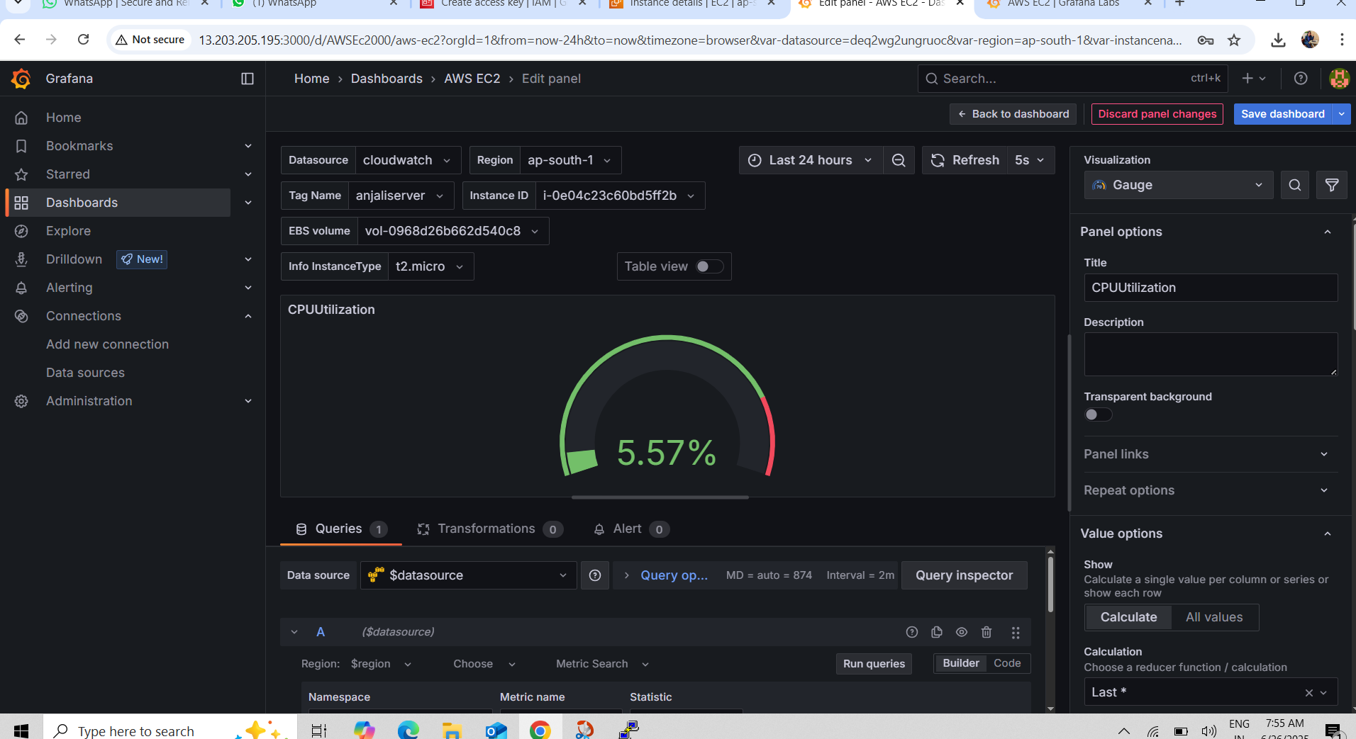

**Thankyou….**